STAFF PROFILE
BIO-DATA
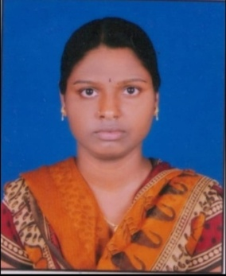

N.SHIREESHA
D/o N. RAJABOGI
Assistant professor Telugu , TTWRDC(M) BOATH.
Contact No: 9833453743
Email: shirishanarmula@gmail.com

Academic Qualifications:

Academic | Institution | % of Marks | Year of passing
Ph.D. in Telugu | Telangana University | Pursuing
IMA | Hyderabad Central University | 78 | 2013
IMA | Hyderabad Central University | 78 | 2016
Intermediate (PDC) | SLNSA | 77 | 2010
S.S.C | ZPHS | 72 | 2008

Teaching experience:

- Working as Assistant Professor in Telugu at TTWRDC(M), Boath at Adilabad, Telangana State, since 11th August 2019.

Additional Qualifications:

- Qualified TS-SET in the year 2018.
- Qualified UGC -NET in the year 2018.

Awards:
Received vangoori chittenraju foundation jatiya yuvasahiti sammelanam award.

List of Publications:

- Published poem .Book titled jatiya yuva sahithi sammalanam NAVARASANARI MANI titled as poem.(Kavitha).

Personal Profile:
Name : N.Shireesha
Father’s Name : N.Rajabogi
Date of Birth : 13/06/1992
Nationality : Indian
Religion : Hindu
Marital Status : Married
Languages Known : Telugu and Hindi.

PERSONAL DETAILS
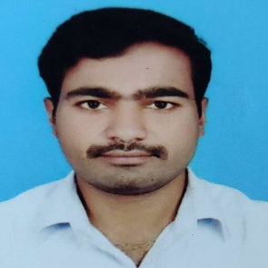
NAME | Dr. GANDRA MAHESH
FATHER NAME | GANDRA MALLAIAH
MOTHER NAME | GANDRA RADHAMMA
DESIGNATION | Degree Lecturer in Telugu
WORKING INSTITUTION | TTWRDC (M) BOATH @ ADILABAD
INSTITUTION TYPE | TRIBAL WELFARE
GENDER | MALE
RELIGION | HINDU
CATEGORY / CASTE | BC
SUB – CASTE | MUNNURU KAPU
DATE OF BIRTH | 08/07/1991
DATE OF JOINING | 06/09/2017
BLOOD GROUP | B+ ve

ADDRESS: (PERMANENT ADDRESS)
H.NO | 5-50/A/9/11
STREET / VILLAGE | THUNGUR
LAND MARK | THUNGUR
MANDAL | BEERPUR
DISTRICT | JAGTIAL
STATE | TELANGANA
COUNTRY | INDIA
PIN CODE | 505454

CANTACT INFO
EMAIL | gandra.mahi@gmail.com
MOBILE NUMBER | +91 9989872717

QUALIFICATION DETAILS
Qualification | Year of Pass | Hall Ticket Number | Maximum Marks | Secured Marks | Percentage | Institution/ University | Institution Address
SSC | 2005-06 | 1017580 | 600 | 475 | 79.1% | ZPHS | THUNGUR, BEERPUR, JAGTIAL Dist.
INTER | 2006-08 | 047072021 | 1000 | 695 | 69.5% | SLNSA KALASHALA | DHARMAPURI, JAGTIAL Dist.
GRADUATION DEGREE | 2008-11 | 047093008 | 1600 | 1224 | 76.5% | SLNSA KALASHALA | DHARMAPURI, JAGTIAL Dist.
POST GRADUATION DEGREE | 2011-13 | 11HTMA25 | 10.00 | 9.17 | 87.63% | UNIVERSITY OF HYDERABAD | HYDERABAD
M.Phil | 2013-14 | 13HT | 10.00 | 8.75 | 83.75% | UNIVERSITY OF HYDERABAD | HYDERABAD
Ph.D | 2014-22 | 14HTPH03 | KARIMNAGAR ZILLA KATHA SAHITYAM VASTU, SHILPA ADHYAYANAM (1991-2010) |  |  | UNIVERSITY OF HYDERABAD | HYDERABAD

ADDITIONAL QUALIFICATIONS

SET (STATE ELIGIBILITY TEST) | 2012 JULY | 112300539 | QUALIFIED |  | GOVERNMENT OF ANDHRAPRADESH
UGC NET | 2013 JUNE | 46270052 | QUALIFIED |  | UNIVERSITY GRANTS COMMISSION,  NEW DELHI.
UGC NET & JRF | 2013 DEC | 46270009 | QUALIFIED UGC – NET for JUNIOR RESEARCH FELLOWSHIP |  | UNIVERSITY GRANTS COMMISSION,  NEW DELHI
TPT (TELUGU PANDIT TRAINING) | 2014 | 1412202037 | 1000 | 662 | 66.2% | OFFICE OF THE DIRECTOR FOR GOVERNMENT EXAMINATIONS, TELANGANA | HYDERABAD
M.A SANSKRIT | 2019 | 50321617002 | 800 | 403 | 50.3% | POTTI SRIRAMULU TELUGU UNIVERSITY | HYDERABAD

TEACHING EXPERIENCE:
- Working as Assistant Professor in Commerce at TTWRDC(M), Boath at Adilabad, Telangana State, since 06th September 2017.
AWARDS:
- “ALISHETTI PRABHAKAR SMARAKA PURASKAARAM” Award Received from Kala Samithi Jagitial on 12th January 2022.

